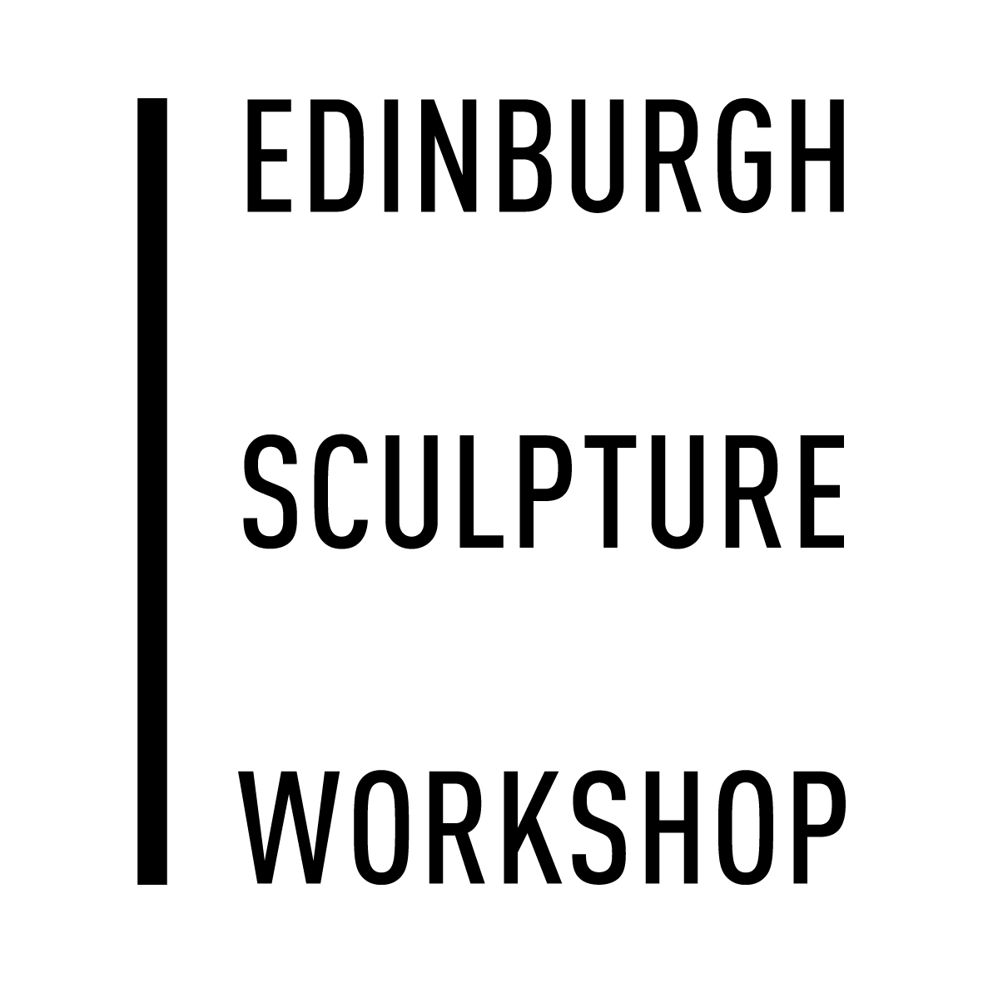 | Graduate Bursary Information Sheet  Deadline: Friday 19th June 2017 @ 5 pm
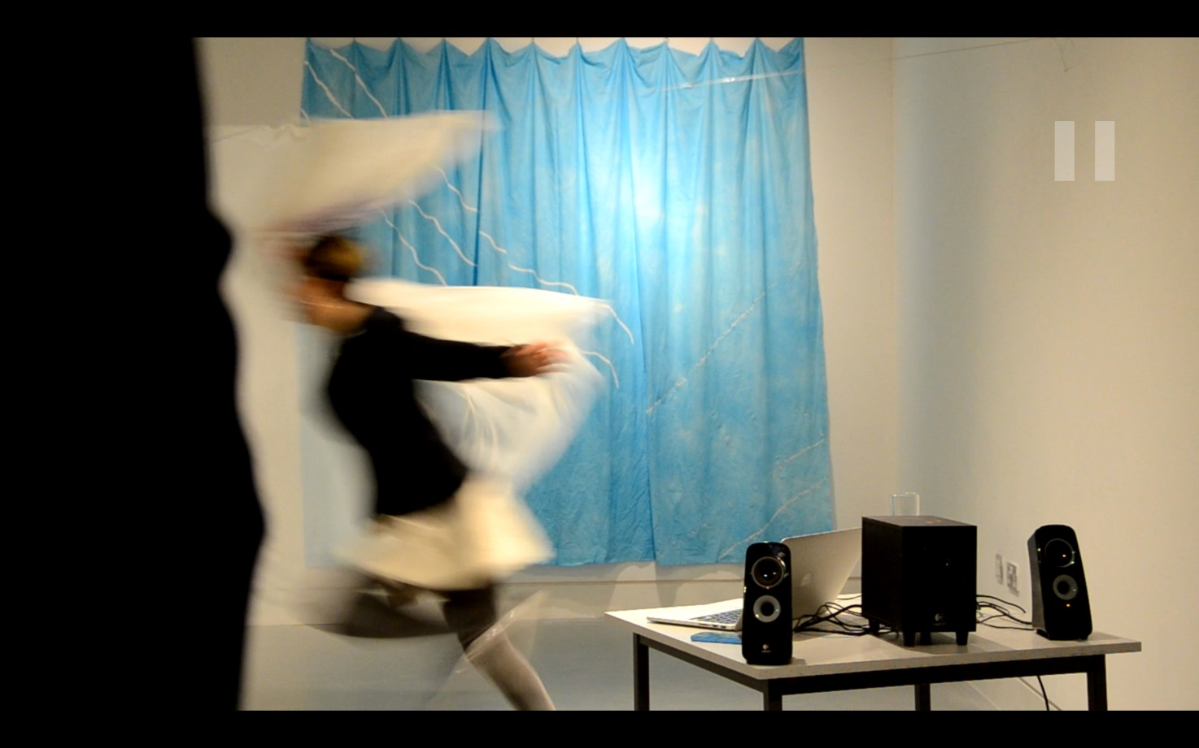
Image: The Weather Channel, Anna Danielewicz, ECA/ESW Bursary Artist 2016/17

Each year Edinburgh Sculpture Workshop, in collaboration with ECA School of Art, offers a Bursary for students graduating from ECA’s School of Art BA, MA or MFA courses.
The aim of the bursary is to help emerging newly-graduated artists to establish themselves after leaving college, make connections with ESW’s artist’s network and encourage contemporary sculpture practice in its widest sense.

Bursary entitles the successful applicant to:
- £500 towards materials
- A free studio at Edinburgh Sculpture Workshop for 3 months September – November 2016
- Full access to the workshop equipment and facilities (charges apply to consumables)
- Experience of working alongside established artists
- Support from the technical, administrative and programme staff at ESW
- An end of project exhibition in one of ESW’s spaces
- 1 year's free membership of ESW

Conditions of Bursary
- The bursary must be carried out over three consecutive months at ESW
- Collaborative proposals will be accepted but the award must be shared

How to apply:
Please complete the application form, and send with the following:
- A one-page statement of outlining your practice, your interest in the Residency, and how it will benefit your work.
- CVs of all artists involved
- Supporting material - This must be in the form of a pdf containing up to 8 images and no larger than 10mb in size. You can include links to work online and your website within this document. If you want to include moving image/sound work in your application either include links to your work online or send them via dropbox or a similar file sharing utility.

Applications should be sent by e-mail to dan@edinburghsculpture.org with 2017 BURSARY in the subject line

Receipt of all applications will be acknowledged within 2 days please contact the office if you don’t receive this acknowledgement by then.

If you have any further questions about any aspect of the application please feel free to phone 0131 551 4490 or to e-mail
dan@edinburghsculpture.org.

Edinburgh Sculpture Workshop background Information
ESW supports emerging and established artists and seeks to promote sculpture and contemporary artistic practice to diverse audiences by encouraging excellence, innovation, experimentation and debate across all areas of our activity.
As well as providing studios and fully-equipped wood and metal workshops, ESW staff is on hand to provide technical and administrative support to artists. There is an IT suite with Mac and digital equipment and free internet access is available.
Successful applicants will be offered 1 year's free membership dating from the beginning of the bursary award.

As well as having 24hr access to their studio residents can make use of the workshop facilities, spaces and research resources available. This is the UK’s first building of this type and operates within a framework designed to empower artists. There are two apartments onsite, one of which is suitable for families.

Edinburgh Sculpture Workshop is based in Newhaven close the cultural hub of Leith and with easy access to the centre of Edinburgh. This places it within a network of galleries, museums, arts festivals and technical facilities. The residency also provides opportunities for networking between residents and the broader cultural life of Scotland.

Selection Panels and Timescales
All of Edinburgh Sculpture Workshop’s artistic activities are selected by a panel of arts professionals.

Feedback
ESW will inform all applicants of the outcome of the process and offer feedback on unsuccessful applications if requested.

